Egyptian Numeral System
# Source: AI Source: Provided by: [Data Path: Persons Table -> ID Column: 1, Name_En Column: Motasem Essam] -> From: [ChatGPT] on [7/16/2026]
The Egyptian Numeral System is an ancient non-positional numeral system developed by the Ancient Egyptians around 3000 BCE. It represents numbers using a collection of hieroglyphic symbols, where each symbol has a fixed value regardless of its position.
Unlike modern positional numeral systems, the Egyptian system does not use place value or a base (radix). Numbers are formed by repeating symbols and adding their values together.
The Egyptian numeral system was widely used in administration, taxation, trade, architecture, engineering, astronomy, and record keeping in Ancient Egypt.

Definition
# Source: AI Source: Provided by: [Data Path: Persons Table -> ID Column: 1, Name_En Column: Motasem Essam] -> From: [ChatGPT] on [7/16/2026]
The Egyptian Numeral System is a non-positional numeral system that represents numbers using hieroglyphic symbols with fixed numerical values.
Each symbol always has the same value, regardless of its position.

Type of Numeral System
# Source: AI Source: Provided by: [Data Path: Persons Table -> ID Column: 1, Name_En Column: Motasem Essam] -> From: [ChatGPT] on [7/16/2026]
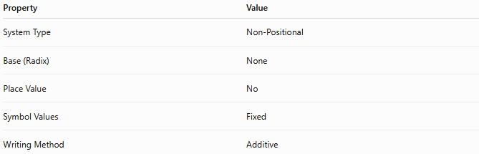
Property | Value
System Type | Non-Positional
Base (Radix) | None
Place Value | No
Symbol Values | Fixed
Writing Method | Additive

Basic Principle
# Source: AI Source: Provided by: [Data Path: Persons Table -> ID Column: 1, Name_En Column: Motasem Essam] -> From: [ChatGPT] on [7/16/2026]
Each symbol represents a fixed power of ten.
Numbers are formed by:
- Repeating symbols
- Adding their values together
There is no positional weighting.

Egyptian Numeral Symbols
# Source: AI Source: Provided by: [Data Path: Persons Table -> ID Column: 1, Name_En Column: Motasem Essam] -> From: [ChatGPT] on [7/16/2026]
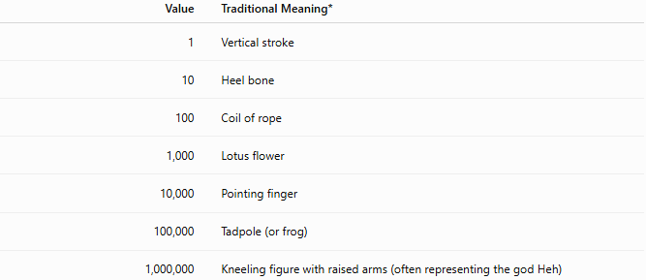
Value | Traditional Meaning*
1 | Vertical stroke
10 | Heel bone
100 | Coil of rope
1,000 | Lotus flower
10,000 | Pointing finger
100,000 | Tadpole (or frog)
1,000,000 | Kneeling figure with raised arms (often representing the god Heh)
*Modern descriptions of the hieroglyphs commonly used in textbooks.

Writing Numbers
# Source: AI Source: Provided by: [Data Path: Persons Table -> ID Column: 1, Name_En Column: Motasem Essam] -> From: [ChatGPT] on [7/16/2026]
Numbers are written by repeating each symbol as many times as needed.
For example,
Number 23
$$23=10+10+1+1+1$$
would be written using
- two symbols for 10
- three symbols for 1

Number 342
$$342=300+40+2$$
would be written using
- three 100-symbols
- four 10-symbols
- two 1-symbols

Number 1,234
$$1234=1000+200+30+4$$
would be written using
- one 1000-symbol
- two 100-symbols
- three 10-symbols
- four 1-symbols

Examples
# Source: AI Source: Provided by: [Data Path: Persons Table -> ID Column: 1, Name_En Column: Motasem Essam] -> From: [ChatGPT] on [7/16/2026]
Example 1
Number
$$17$$
Expanded form
$$10+1+1+1+1+1+1+1$$

Example 2
Number
$$245$$
Expanded form
$$200+40+5$$

Example 3
Number
$$3582$$
Expanded form
$$3000+500+80+2$$

Characteristics
# Source: AI Source: Provided by: [Data Path: Persons Table -> ID Column: 1, Name_En Column: Motasem Essam] -> From: [ChatGPT] on [7/16/2026]
The Egyptian numeral system:
- Is non-positional.
- Uses an additive notation.
- Has fixed-value symbols.
- Uses separate symbols for powers of ten.
- Does not use place value.
- Does not require a base.

Zero
# Source: AI Source: Provided by: [Data Path: Persons Table -> ID Column: 1, Name_En Column: Motasem Essam] -> From: [ChatGPT] on [7/16/2026]
The classical Egyptian numeral system did not have a symbol for zero.
Later Egyptian mathematical texts sometimes used placeholder concepts, but zero was not part of the original numeral system.

Negative Numbers
# Source: AI Source: Provided by: [Data Path: Persons Table -> ID Column: 1, Name_En Column: Motasem Essam] -> From: [ChatGPT] on [7/16/2026]
The Egyptian numeral system was not designed to represent negative numbers.
It was primarily used for counting and measuring positive quantities.

Fractions
# Source: AI Source: Provided by: [Data Path: Persons Table -> ID Column: 1, Name_En Column: Motasem Essam] -> From: [ChatGPT] on [7/16/2026]
The Egyptians developed a separate method for representing fractions.
Most fractions were written as unit fractions, meaning fractions with numerator 1.
Examples:
$$\frac{1}{2}, \frac{1}{3}, \frac{1}{4}$$
Special symbols existed for a few common fractions such as
$$\frac{2}{3}.$$

Advantages
# Source: AI Source: Provided by: [Data Path: Persons Table -> ID Column: 1, Name_En Column: Motasem Essam] -> From: [ChatGPT] on [7/16/2026]
The Egyptian numeral system:
- Is easy to understand for counting.
- Clearly represents powers of ten.
- Is well suited for recording inventories and quantities.
- Was practical for administrative purposes.

Disadvantages
# Source: AI Source: Provided by: [Data Path: Persons Table -> ID Column: 1, Name_En Column: Motasem Essam] -> From: [ChatGPT] on [7/16/2026]
The Egyptian numeral system:
- Requires many repeated symbols.
- Becomes cumbersome for large numbers.
- Does not use place value.
- Makes arithmetic operations difficult.
- Does not naturally represent zero or negative numbers.

Applications
# Source: AI Source: Provided by: [Data Path: Persons Table -> ID Column: 1, Name_En Column: Motasem Essam] -> From: [ChatGPT] on [7/16/2026]
The Egyptian numeral system was used in:
- Tax collection
- Agriculture
- Architecture
- Construction
- Trade
- Accounting
- Census records
- Astronomy
- Engineering
- Monument inscriptions

Historical Importance
# Source: AI Source: Provided by: [Data Path: Persons Table -> ID Column: 1, Name_En Column: Motasem Essam] -> From: [ChatGPT] on [7/16/2026]
The Egyptian numeral system is one of the earliest known written numeral systems.
It influenced the development of later mathematical notation and demonstrates the early use of decimal grouping, even though it was not a positional decimal system.

Common Mistakes
# Source: AI Source: Provided by: [Data Path: Persons Table -> ID Column: 1, Name_En Column: Motasem Essam] -> From: [ChatGPT] on [7/16/2026]
- Thinking it is a positional system.
- Assuming it uses place value.
- Believing it has a base like decimal or binary.
- Confusing it with Roman numerals.

Key Points
- The Egyptian numeral system is non-positional.
- Every symbol has a fixed value.
- Numbers are formed by adding repeated symbols.
- Separate symbols represent powers of ten.
- It does not use place value or zero.

Egyptian Numeral System vs. Decimal System
# Source: AI Source: Provided by: [Data Path: Persons Table -> ID Column: 1, Name_En Column: Motasem Essam] -> From: [ChatGPT] on [7/16/2026]
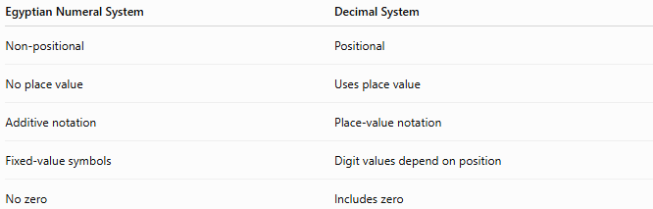
Egyptian Numeral System | Decimal System
Non-positional | Positional
No place value | Uses place value
Additive notation | Place-value notation
Fixed-value symbols | Digit values depend on position
No zero | Includes zero

Egyptian Numeral System vs. Roman Numerals
# Source: AI Source: Provided by: [Data Path: Persons Table -> ID Column: 1, Name_En Column: Motasem Essam] -> From: [ChatGPT] on [7/16/2026]
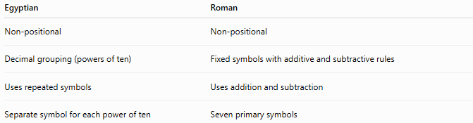
Egyptian | Roman
Non-positional | Non-positional
Decimal grouping (powers of ten) | Fixed symbols with additive and subtractive rules
Uses repeated symbols | Uses addition and subtraction
Separate symbol for each power of ten | Seven primary symbols

Egyptian Numeral System vs. Modern Positional Systems
# Source: AI Source: Provided by: [Data Path: Persons Table -> ID Column: 1, Name_En Column: Motasem Essam] -> From: [ChatGPT] on [7/16/2026]
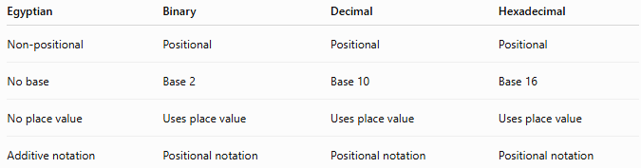
Egyptian | Binary | Decimal | Hexadecimal
Non-positional | Positional | Positional | Positional
No base | Base 2 | Base 10 | Base 16
No place value | Uses place value | Uses place value | Uses place value
Additive notation | Positional notation | Positional notation | Positional notation

Conclusion
# Source: AI Source: Provided by: [Data Path: Persons Table -> ID Column: 1, Name_En Column: Motasem Essam] -> From: [ChatGPT] on [7/16/2026]
The Egyptian Numeral System is an ancient non-positional numeral system that represents numbers using hieroglyphic symbols with fixed values. Numbers are formed by repeating symbols and adding their values, without using place value or a positional base. Although it was eventually replaced by more efficient positional numeral systems, the Egyptian numeral system played a significant role in the history of mathematics and was essential for administration, engineering, trade, and scientific activities in Ancient Egypt.

